AIML SESSION 01 ASSIGNMENT SUBMISSION

  - Name of student: Vaibhav Vijay Kate
Domain/subject name: AIML (Artificial Intelligence & Machine Learning)
College and Branch name: Government Polytechnic Washim (Information Technology

Task 1: Variables & Naming Rules
Program Code:
# S1Q1.py - Variables & Naming Rules
# Storing personal details
full_name = "Vaibhav Vijay Kate"
age = 17
height_in_meters = 1.76
is_student = True
# Printing values
print("Name:", full_name)
print("Age:", age)
print("Height:", height_in_meters, "meters")
print("Is Student:", is_student)
print("\n--- Checking Data Types ---")
# Checking data types using type()
print("full_name type:", type(full_name))
print("age type:", type(age))
print("height_in_meters type:", type(height_in_meters))
print("is_student type:", type(is_student))

OUTPUT Screenshot:
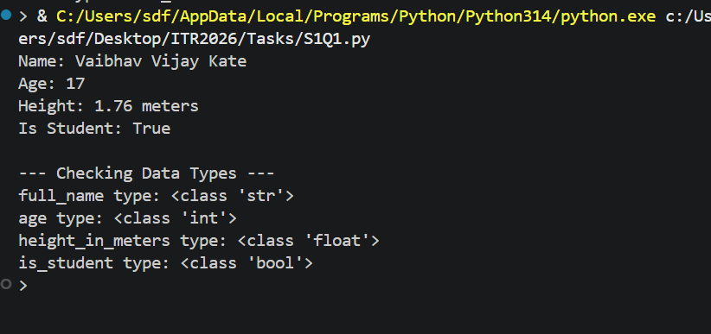
Task 2: Core Data Types & Typecasting
Program Code:
# S1Q2.py - Core Data Types & Typecasting
# Creating variables of core types
my_string = "Hello AIML"
my_integer = 15
my_float = 9.81
my_boolean = False
# Printing variables and their types
print("String:", my_string, "| Type:", type(my_string))
print("Integer:", my_integer, "| Type:", type(my_integer))
print("Float:", my_float, "| Type:", type(my_float))
print("Boolean:", my_boolean, "| Type:", type(my_boolean))
print("\n--- Type Conversion ---")
# Converting types
converted_int_to_float = float(my_integer)
converted_float_to_int = int(my_float)
print("Int to Float:", converted_int_to_float)
print("Float to Int (Truncated):", converted_float_to_int)

OUTPUT Screenshot:
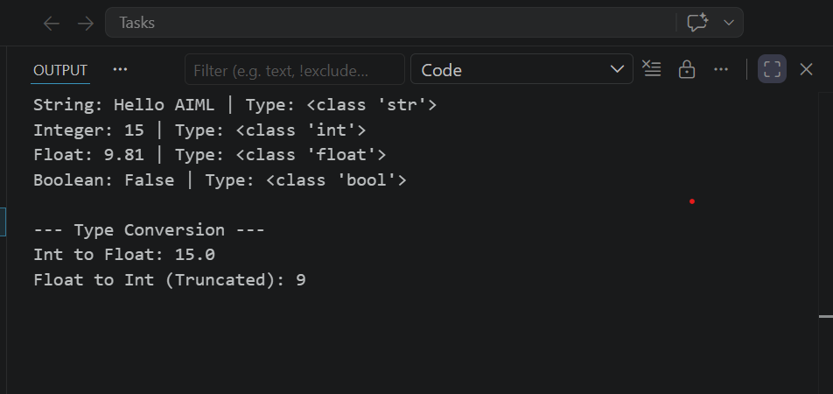
Task 3: Arithmetic Operators
Program Code:
# S1Q3.py - Arithmetic Operators
a = 15
b = 4
# Performing operations
print("Addition (a + b):", a + b)
print("Subtraction (a - b):", a - b)
print("Multiplication (a * b):", a * b)
print("Division (a / b):", a / b)
print("Floor Division (a // b):", a // b)
print("Modulo (a % b):", a % b)
print("Exponentiation (a ** b):", a ** b)
# Note: '/' gives floating quotient (e.g. 15 / 4 = 3.75)
# '//' rounds down division to nearest lower integer (e.g. 15 // 4 = 3)

OUTPUT Screenshot:
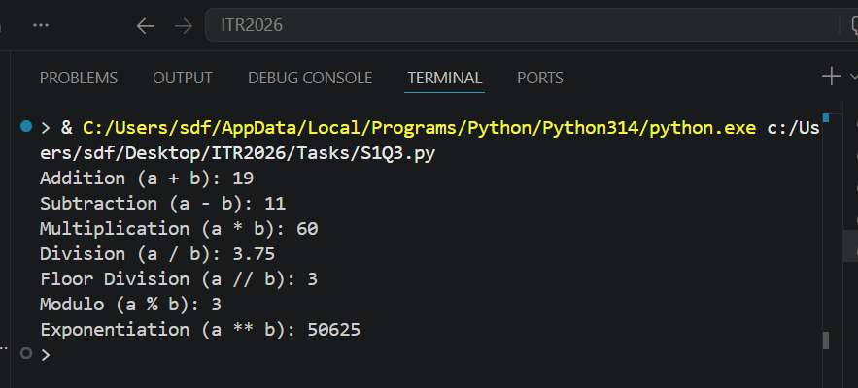
Task 4: Comparison & Logical Operators
Program Code:
# S1Q4.py - Comparison & Logical Operators
x = 25
y = 30
z = 25
# Evaluating expressions
print("1. Is x greater than y?:", x > y)
print("2. Is x equal to z?:", x == z)
print("3. Is x <= y AND y != z?:", (x <= y) and (y != z))
print("4. Is x > y OR x == z?:", (x > y) or (x == z))

OUTPUT Screenshot:
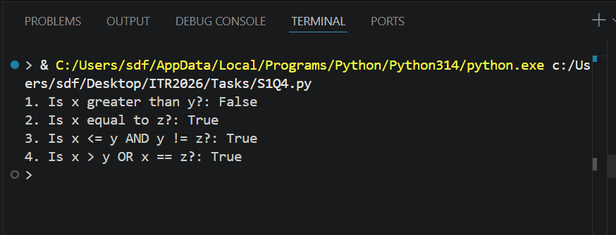
Task 5: Input/Output (Age Calculator)
Program Code:
# S1Q5.py - Input/Output & Typecasting
# Getting user inputs
name = input("Enter your name: ")
birth_year_str = input("Enter your birth year: ")
# input() returns string, so we convert birth_year to int for calculation
birth_year = int(birth_year_str)
age = 2026 - birth_year
print(f"\nHello {name}!")
print(f"Your age in 2026 will be {age} years.")

OUTPUT Screenshot:
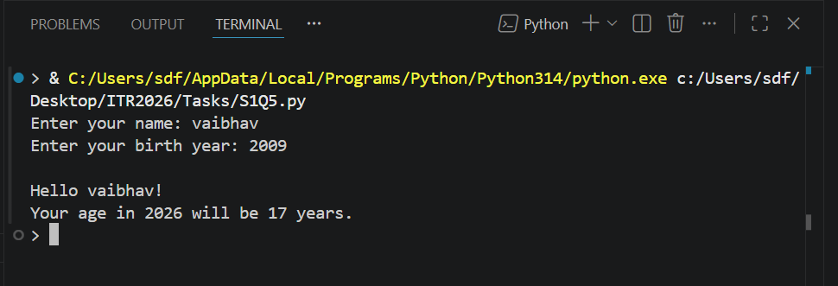
Task 6: BMI Calculator
Program Code:
# S1Q6.py - BMI Calculator
print("--- BMI Calculator ---")
# Inputs converted to float for decimal values
weight = float(input("Enter weight (kg): "))
height = float(input("Enter height (meters): "))
# BMI formula
bmi = weight / (height ** 2)
print(f"\nYour BMI is: {round(bmi, 2)}")
if bmi < 18.5:
print("Category: Underweight")
elif 18.5 <= bmi < 25:
print("Category: Normal weight")
else:
print("Category: Overweight")

OUTPUT Screenshot:
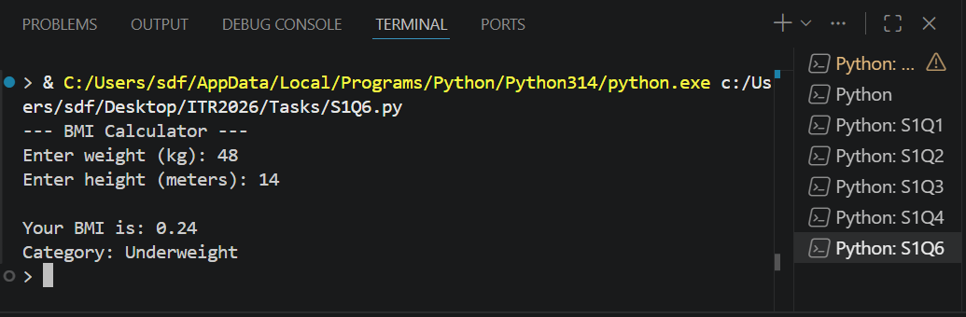
Task 7: Area & Perimeter of a Rectangle
Program Code:
# S1Q7.py - Rectangle Area & Perimeter
"""
Calculates area and perimeter of a rectangle
based on user length and width.
"""
# Dimensions can have decimals, so we use float
length = float(input("Enter length: "))
width = float(input("Enter width: "))
# Area = length * width
area = length * width
# Perimeter = 2 * (length + width)
perimeter = 2 * (length + width)
print(f"\nArea: {area} sq units")
print(f"Perimeter: {perimeter} units")

OUTPUT Screenshot:
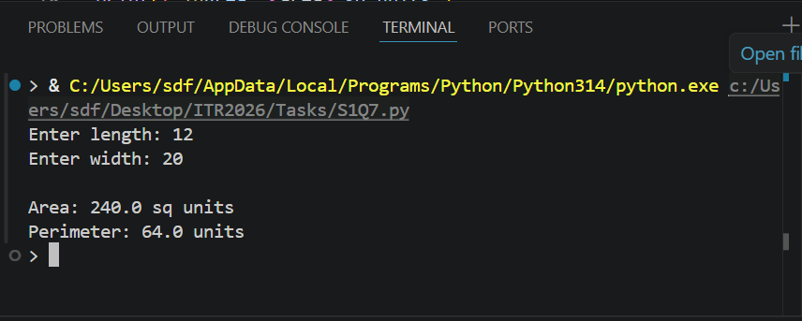
Task 8: Assignment & Membership Operators
Program Code:
# S1Q8.py - Assignment & Membership Operators
fruits = ["mango", "apple", "banana", "cherry"]
score = 50
# 1. Update score using += shorthand
score += 25
print("Updated score:", score)
# 2. Check if apple is in the list
print("Is 'apple' in fruits?:", "apple" in fruits)
# 3. Check if grape is not in the list
print("Is 'grape' not in fruits?:", "grape" not in fruits)

OUTPUT Screenshot:
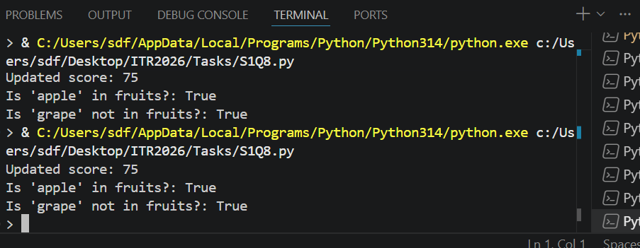
Task 9: Student Profile Generator
Program Code:
# S1Q9.py - Student Profile Generator
print("=== Student Profile Generator ===")
name = input("Enter name: ")
age = int(input("Enter age: "))
city = input("Enter city: ")
# Marks for three subjects
sub1 = float(input("Enter Subject 1 marks: "))
sub2 = float(input("Enter Subject 2 marks: "))
sub3 = float(input("Enter Subject 3 marks: "))
# Total and Percentage calculation
total = sub1 + sub2 + sub3
percentage = (total / 300) * 100
print("\n" + "="*30)
print(" STUDENT PROFILE ")
print("="*30)
print(f"Name : {name}")
print(f"Age : {age} years")
print(f"City : {city}")
print(f"Marks : {sub1}, {sub2}, {sub3}")
print(f"Total : {total}/300")
print(f"Percentage: {percentage:.2f}%")
print("="*30)

OUTPUT Screenshot:
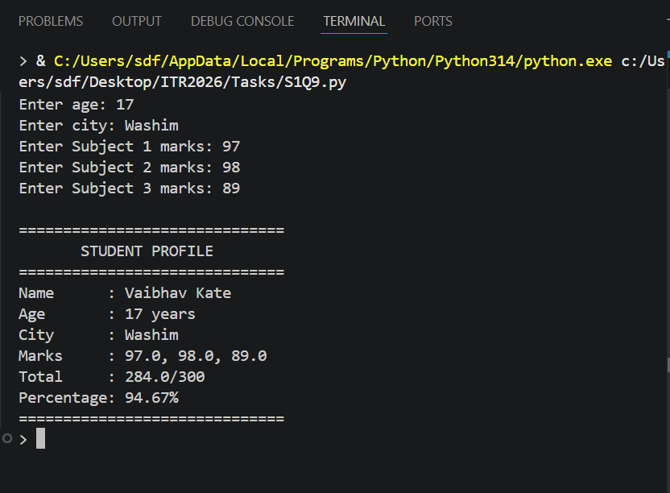
Task 10: Debugging and Fixing Python Code
Program Code:
# S1Q10.py - Debugging Python Code
# Fixes made:
# 1. Added '=' to 'age = 20'
# 2. Wrapped "Amsterdam" in double quotes
# 3. Added space in "My name is "
# 4. Added commas in print statements to avoid syntax errors
# Corrected code
Name = "Alice"
age = 20
city = "Amsterdam"
print("My name is " + Name)
print("I am", age, "years old")
print("I live in", city)
# Check if adult (fixed: added comma)
print("Adult:", age > 18)

OUTPUT Screenshot:
